# Experimental Report

## CP1N4-24721015 李鹏麒

# **所属内容：Experimental N4-C1-20241106**

# **完成部分说明：编写算法与代码、调试与测试、撰写实验报告**

**The programme language**: C language

**The programming platform**: Visual Studio Code

**Program function**:

(1)A program that uses binary search algorithm to query negative integer sequences.

(2)A program that requires the following functions:

Enter the scores of m courses of n students from the keyboard. Calculate the average score of each course, as well as the highest and lowest score. Count the number of students with more than 80 points and failed in each course.

**Program algorithm**:(Specific code is in the folder)

1. First, design an array nums[]. Then, using function designed to arrange the elements in order from small to large. Finally, use the binary search algorithm to query negative integer sequences, using the function ‘if’ to determine if the element is found in the array.
2. First, design an array of two dimensions, input the number of courses and students. Using the function ‘for’ to traverse every element in the array to find the max and the min. Using ‘<’ , ‘>’ and ‘++’ to count the number of the upper and the failed.

**Program flow chart:**

(1)

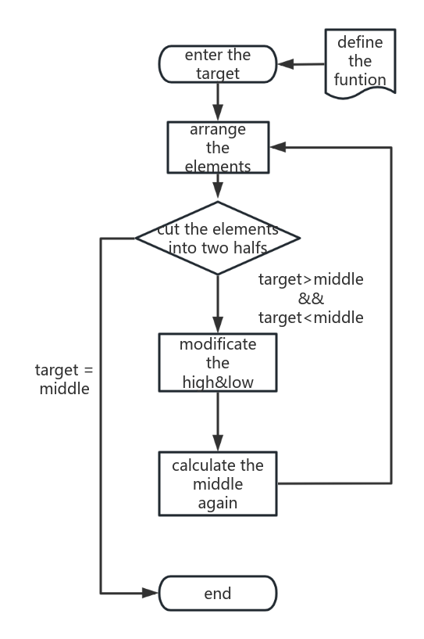

(2)

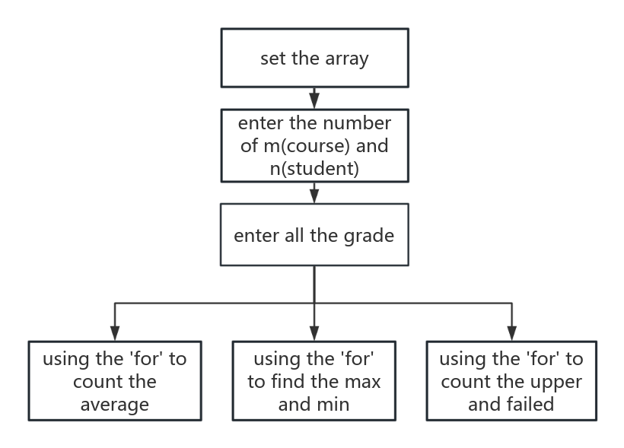

**Program experiment test:**

(1)

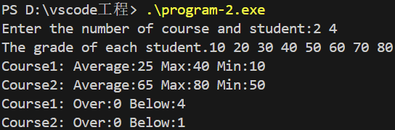

(2)

